**Function Parameter Passing and Return Assignments**

Mandatory

1. Refer the code below and find the issue.

#include<stdio.h>

int *func(void);

int main()

{

int num,*ptr = NULL;

ptr = (int *)func();

num = *ptr;

return 1;

}

int *func()

{

int local;

local = 10;

return(&local);

}

In above code is there a way(s) to return local variable address to caller?

Ans:



2. Write a program with a function read_extract_characters() to read a string (of max length 50 characters) from user, extract the characters at odd indices, store in an other array and return to the call. Caller should be able to read and display the extracted string.

[Note : do not return a local variable in function to caller]

Ans:

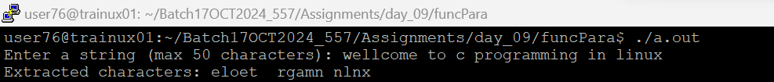

3. Write below functions to extract and return the required inputs from an email id string of max length 80 characters. Program should be able to detect an invalid email id too based on following validations. Also value returned should be in scope and accessible in caller.

a. valid email id will have username, host and domain name (as .com/.edu)

Functions:

char *getuser(char input[]); // return NULL or valid username from email id input

char *gethost(char input[]); //return NULL or valid hostname from email id input

char *getdomain(char input[]); //return NULL or valid domain name from email id input

int isValidDomain(char input[]); // return 1 if domain is “.com” or “.edu” else 0

Ans:

